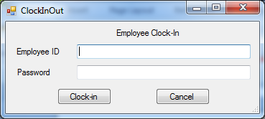

Initial Employee Clock-in on application start.

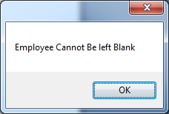

Trying to Clock-in without entering employee number

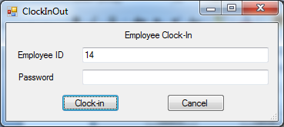

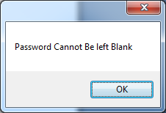

Employee Left Password Blank and tried to Clock-in

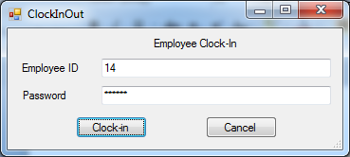

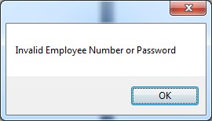

Employee Entered Wrong Password

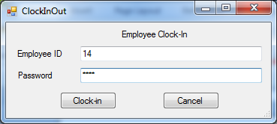

Entered Employee Number and Password

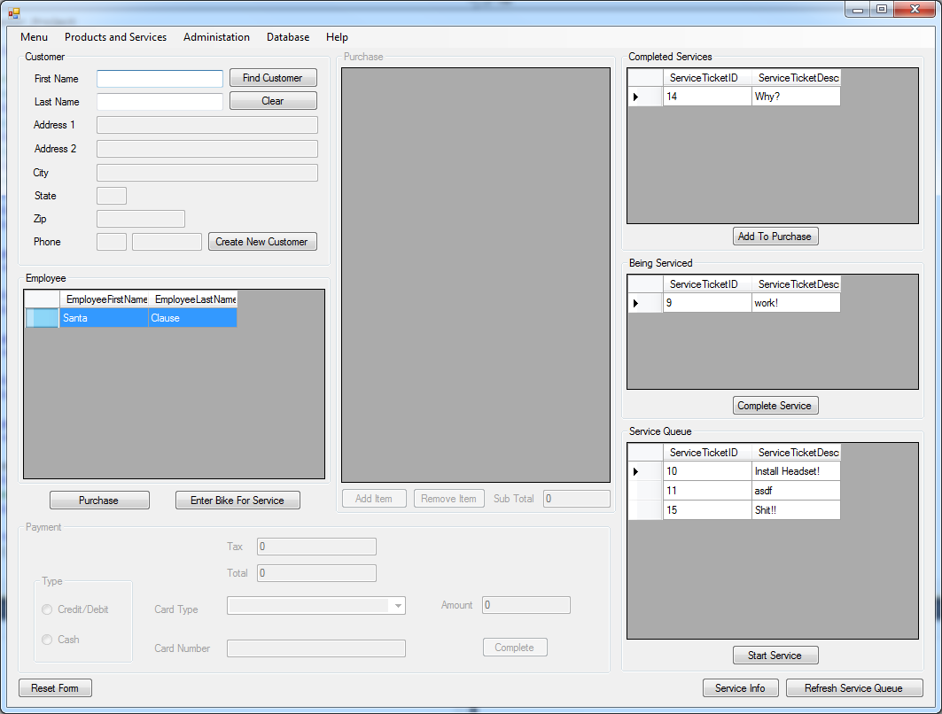

Employee Appears In Employee List

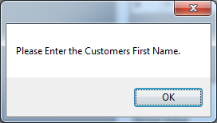

Employee Tries to lookup customer without entering customer first name

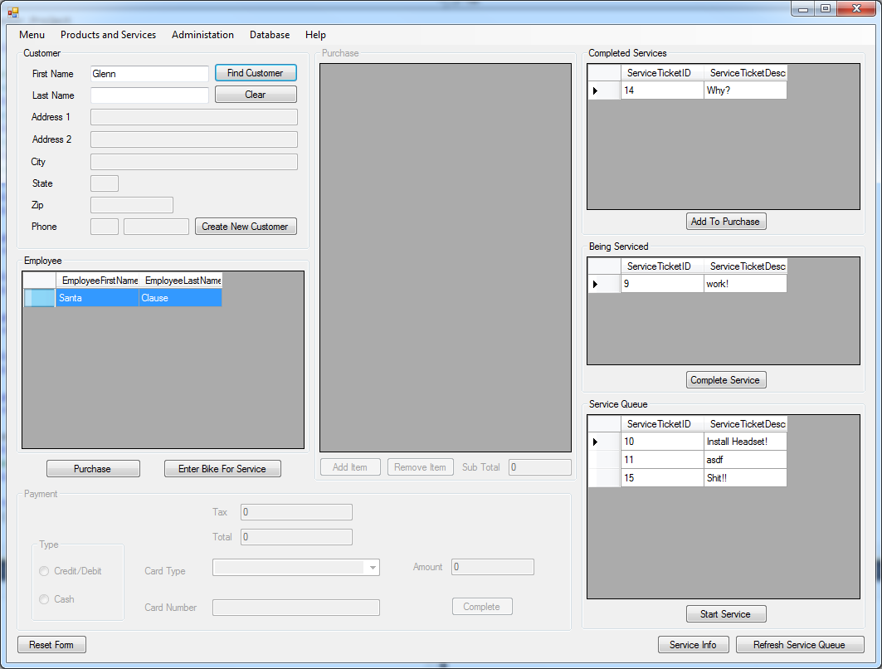

Employee Entered Customer First name but no last name

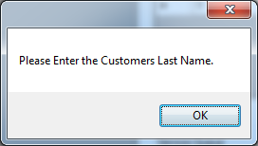

Error message

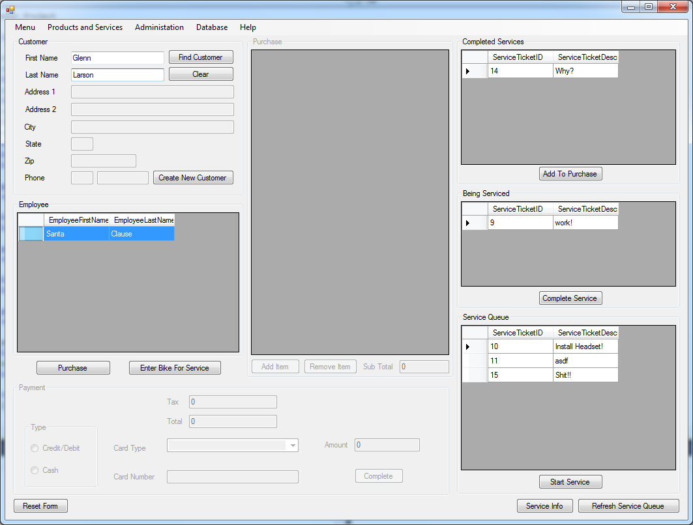

Employee Entered Customers first and last name and clicks find customer

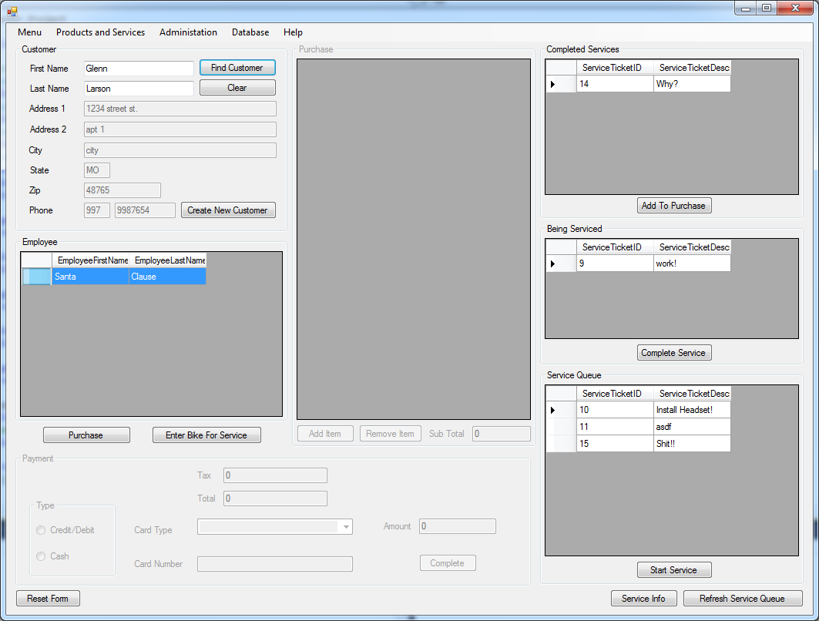

Customer Information is populated

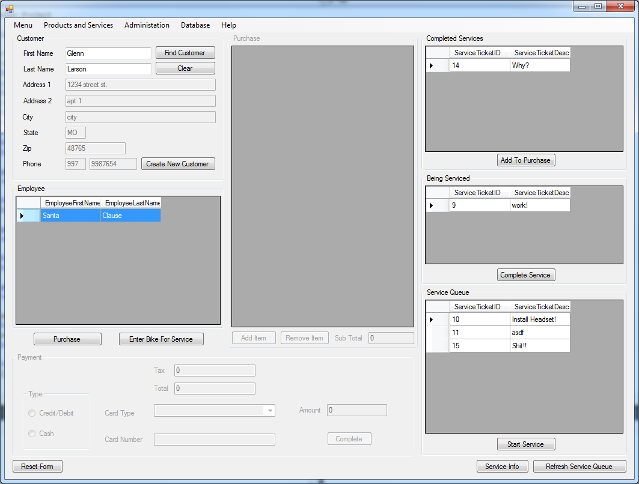

Employee Selects their name from employee working list then Clicks Enter Bike For Service

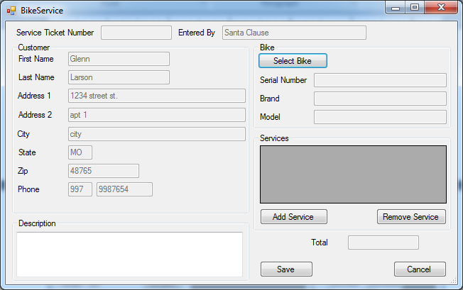

Bike Service Window Appears Populated With Customer Information and The Employees Name who entered it

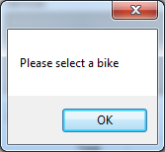

Error when employee tries to add service without selecting bike

The Employee then clicks select bike button

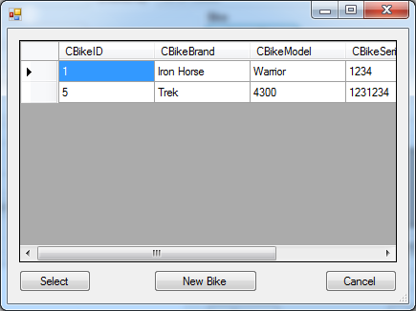

The Customer Bike List appears, if the customer bike isn’t listed then click new bike and enter bike information(Optional)

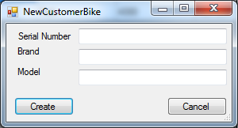

New customer bike Screen appears

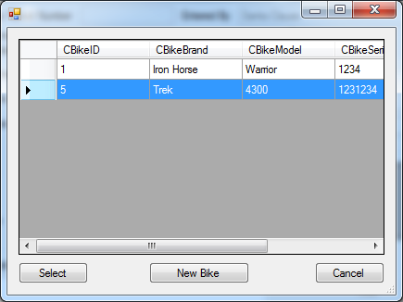

Other wise Employee Selects Bike and clicks select

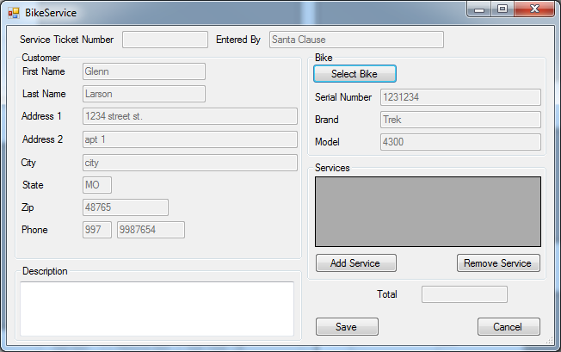

Bike information populates in service ticket window Employee Then Clicks Add Service Btn

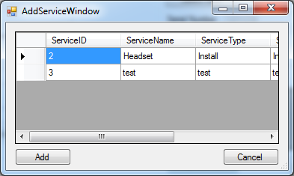

Add service window Appears

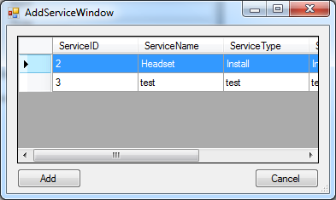

Employee Selects Service

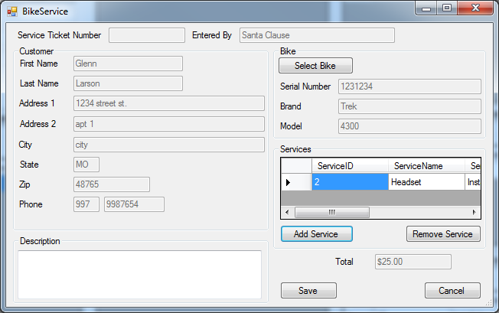

Service appears in List

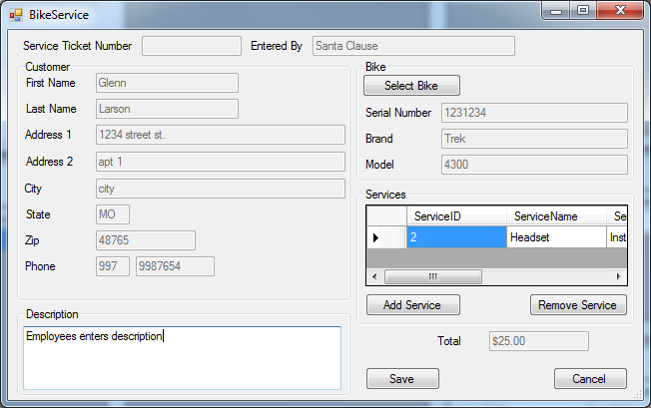

Employee Enters Description and then clicks save

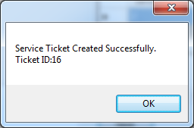

Message saying ticket created successfully and then gives the ticket id

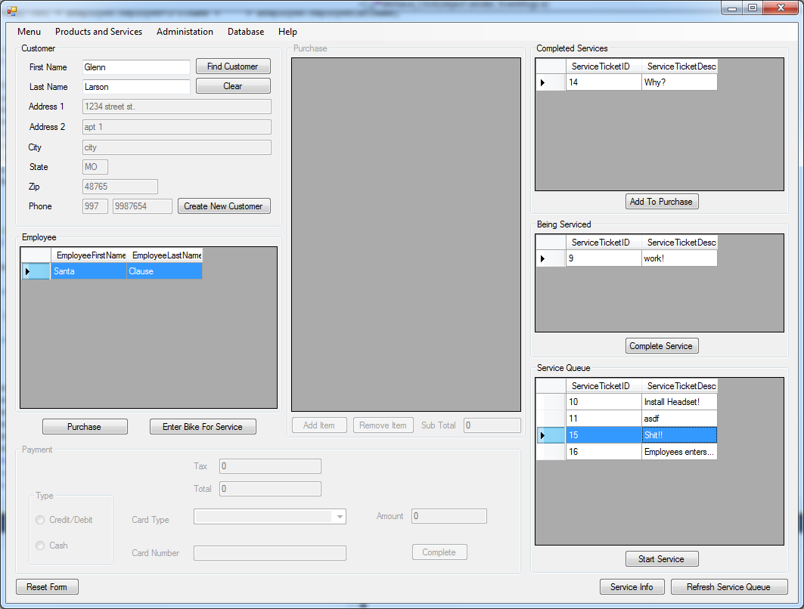

Service ticket appears in service queue